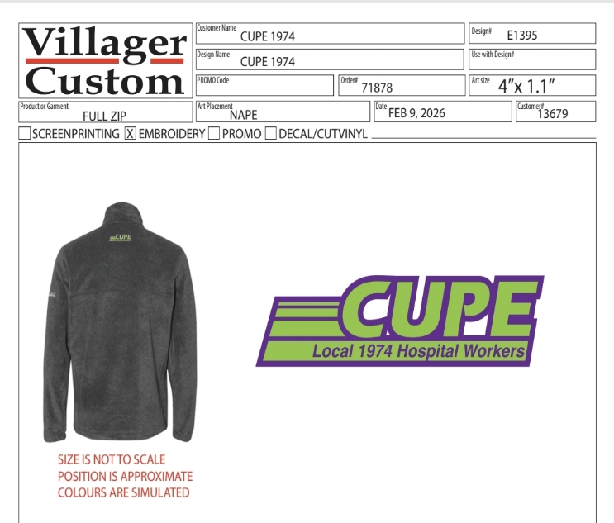
Dark Grey Fleece Columbia Jackets  Women’s Fit – Small – 2XL  Men’s Fit – Small – 3XL | Price per jacket including tax.  $56.74 | CUPE 1974 Logo under collar center back  Embroidered | Left Chest – “classification” i.e.; GFT Secretary, PCA, Porter, etc.  Embroidered  Optional
 | $10.00 deposit when order is placed  Remaining balance due upon pick up | To place your order please send an email to president@cupe1974.ca with the following information. | Right Arm –  “Name”  Embroidered  Optional
You can e-transfer deposit to treasurer@cupe1974.ca or visit the Union Office at HDH or KGH to use cash, debit or credit.

Please Fill Out:
Full Name:________________________________________________________________________________
Fit (Women’s/Male):_______________________________________________________________________
Size:_____________________________________________________________________________________
Classification:____________________________________________________________________________
First Name (to display on sleve):____________________________________________________________

