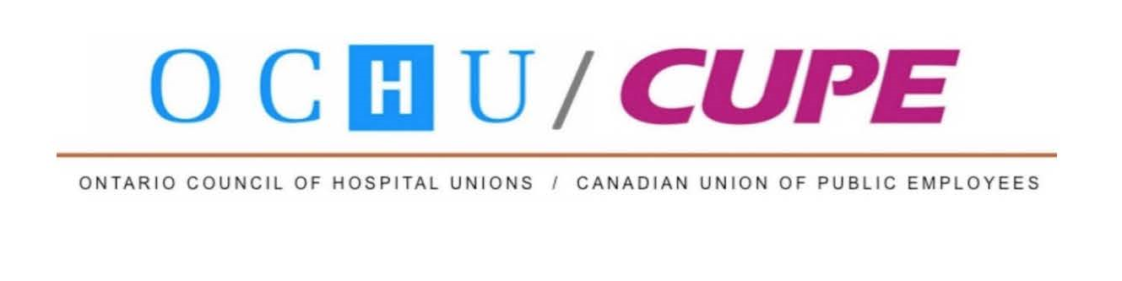

FOR IMMEDIATE RELEASE MEDIA RELEASE JULY 16, 2019

With $8 billion more in cuts coming, Ford PCs “worse than Harris”
Kingston shorted 91 hospital beds, 790 staff, new report finds

KINGSTON, ON – When it comes to hospital funding, Doug Ford’s Progressive Conservative (PC) government is “worse than Mike Harris” new data reports released in Kingston today by the Ontario Council of Hospital Unions (OHCU) show.

For Doug Ford’s Progressive Conservative government to keep its proposed budget plan for the next five years, “it is now apparent that the PCs will need to make larger cuts to hospitals (and health care generally) than previously estimated,” said Michael Hurley, president of the Ontario Council of Hospital Unions (OCHU).

Based on the recent budget and economic review of Ontario’s Financial Accountability Office (FAO), the government’s spending plan needs billions of dollars more in extra, unidentified and unannounced cuts to public services in order to meet its savings targets. The unidentified and unannounced health cuts exist even for this fiscal year – but they become a much bigger issue as the years go along until they account for $5.2 billion out of $8 billion in total cuts required by the government’s fiscal plan in 2023-24.

“Even though the cuts the PCs have identified to date to health care have been major and painful, $5.2 billion is many times more. In communities like Kingston, already dealing with higher rates of disease, cuts at this level will hurt patients greatly and diminish already challenged hospital capacity. The PCs are creating a patient access crisis and hallway health care will get much worse,” said Hurley.

While the cuts imposed by the Mike Harris Progressive Conservative government were particularly painful in its first budget, they lasted only a couple of years before that government was required to reverse its policy in its third year, following widespread community pressure and increased program spending by 8 per cent. The Ford Progressive Conservative government plans at least five years of austerity (there are no reports from the government yet about what it plans to do in years six and beyond). The FAO notes the cuts are similar to the level of cuts in the 1990s, and equal to about 10 per cent in real terms for all program spending – about a $1,100 per person cut (in constant dollars) for all program spending.

Hurley also released ‘Protecting What Matters Most,’ a report based on the 2019 budget restraint numbers, population and aging growth and inflationary costs that shows that for hospitals, the real per capita funding cuts proposed province-wide over five years, are more than 15 per cent. If that level of cuts were applied to Ontario hospitals today province-wide, that would mean 4,012 fewer beds and 28,187 fewer staff to serve our current population, and Kingston will see even less hospital capacity and be shorted 91 beds and 790 hospital staff.

“Our findings show that the PCs are not doing what they said they would do and ‘protecting what matters most.’ Rather, their planned cuts for hospitals are deeper than for other programs. Their plans will sharply intensify the current problems patients have with accessing care in hospitals. Unfortunately, the Premier and health minister are pretending to fix the hospital capacity problem by diverting attention to health system restructuring and skirting around the coming cuts and service privatizations,” said Hurley.

-30-

For more information, please contact:

Michael Hurley, President, OCHU/CUPE, 416-884-0770
Stella Yeadon, CUPE Communications, 416-559-9300, syeadon@cupe.on

COPE491/EW

